Questions qap1

Java script

1. The number of hours for me to complete this assessment was about maybe a hour or a little less or more.
2. I watched some of the lectures before starting.
3. Did not ask any questions to any friends
4. Did not ask any questions to any instructor
5. If I had to give it a rating out of 5 probably like 1 or 2, not hard at all thought it was going to be but wasn’t bad at all

Question 1

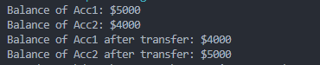

Question 2



Question 3

